Name: Tushar Muley

Assignment: Exercise 5.2 Heat Maps, Spatial Charts, Contour Maps

Date: November 7, 2021

**Tableau Spatial Chart:**

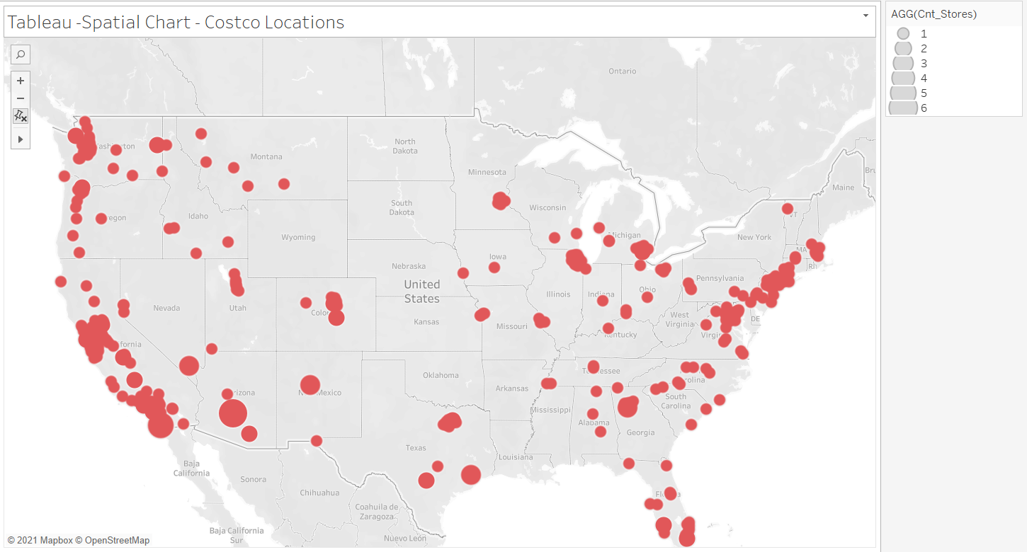

**Tableau Heat Map:**

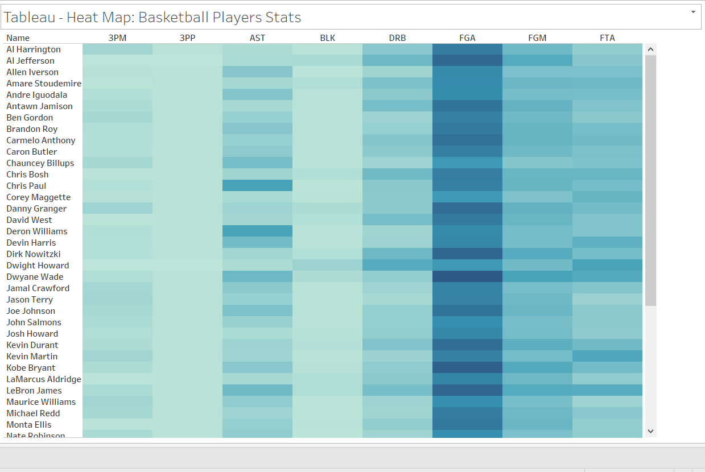

**Tableau Funnel Chart:**

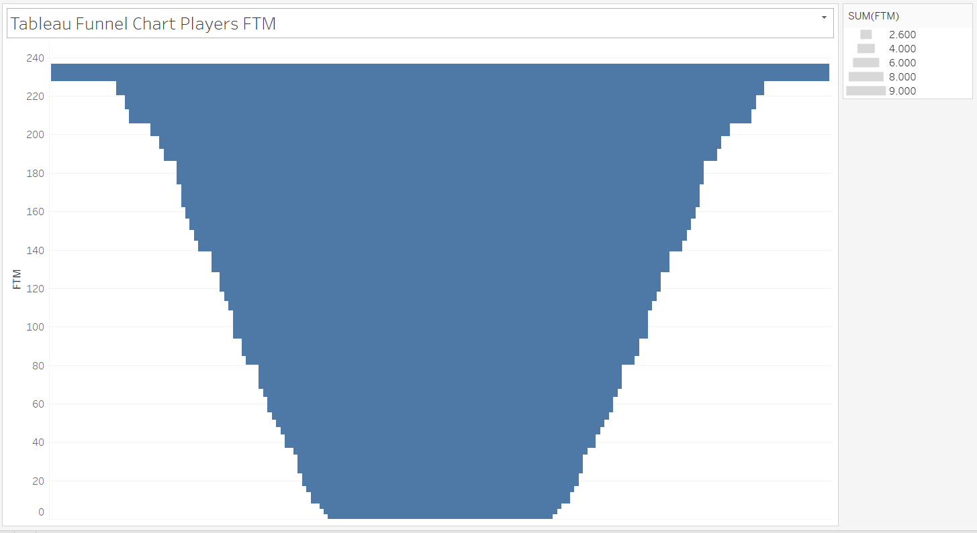

**Python Spatial Chart:**

**Python- Spatial Chart: Costco Locations**

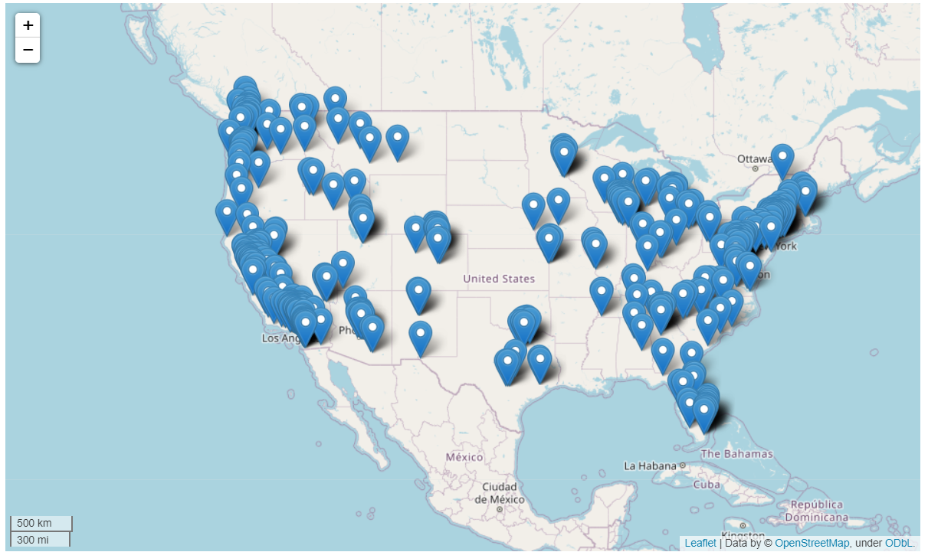

**Python Heat Map:**

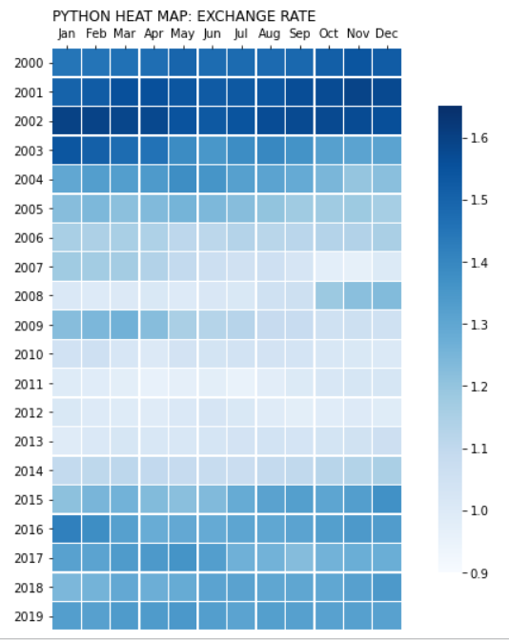

**Python Contour Chart:**

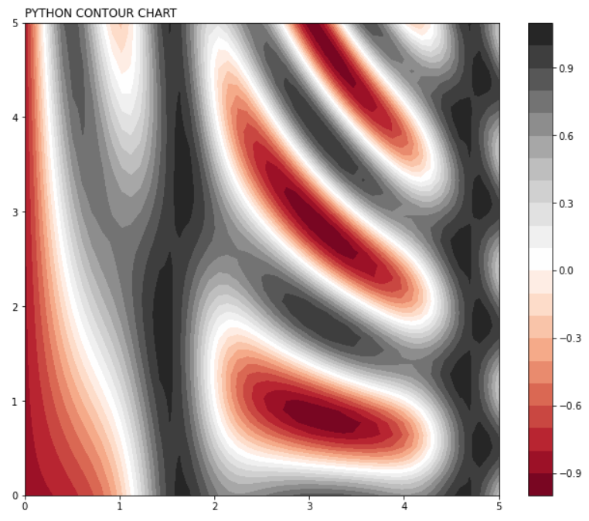

**R Spatial Chart:**

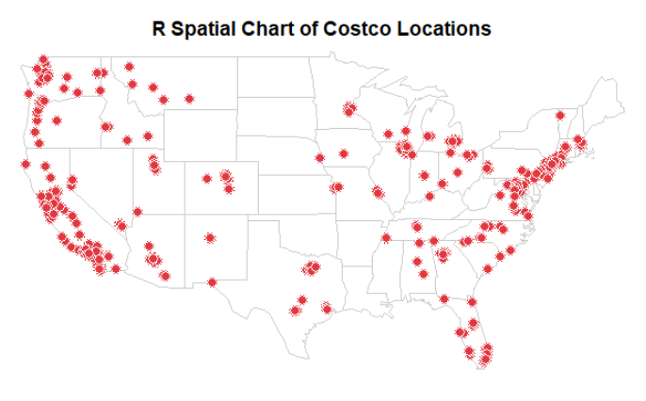

**R Heat Map:**

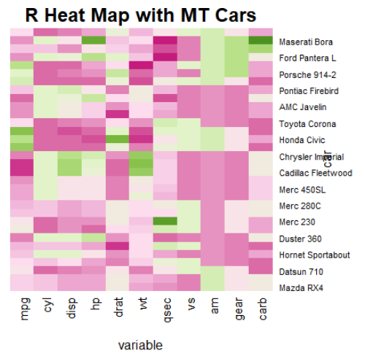

**R Contour Chart:**

